Directories Submission:
S.no | URL | 360schooltrips Screenshot
01 | http://www.pakranks.com/submit.php?c=729&LINK_TYPE=2 | 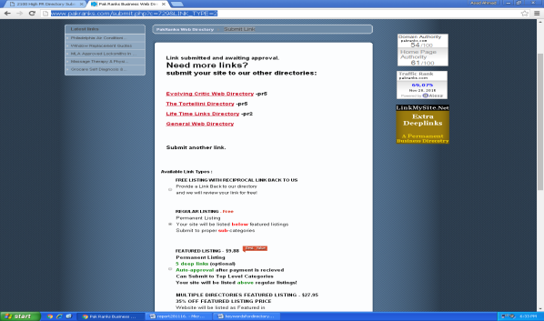
02 | http://www.ewebresource.com/submit.php?c=3483&LINK_TYPE=1 | 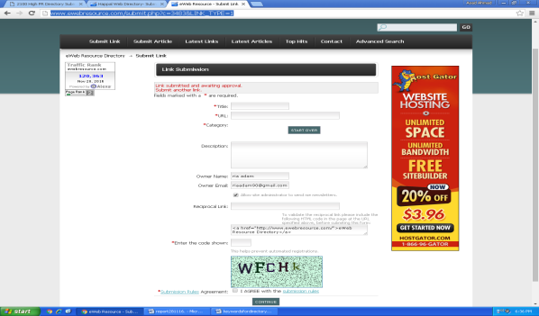
03 | http://www.happal.com/submit.php?c=14&LINK_TYPE=1 | 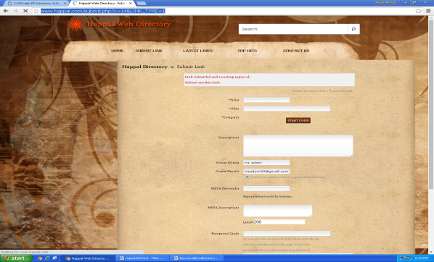
04 | http://www.shistlbb.com/submit.php?c=291&LINK_TYPE=11 | 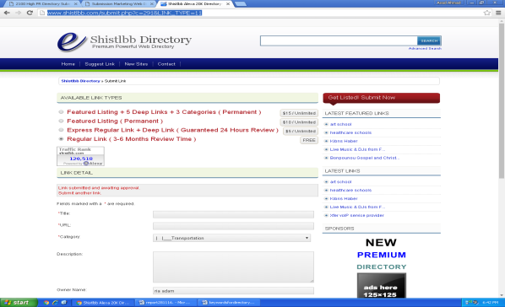
05 | http://www.submissionwebdirectory.com/submit.php | 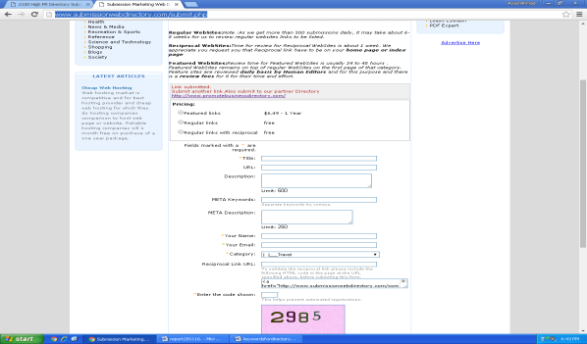
06 | http://www.sitetweets.net/submit.php?c=98&LINK_TYPE=1 | 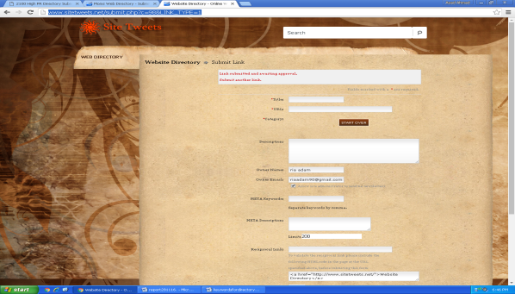
07 | http://www.momsdirectory.net/submit.php?c=1&LINK_TYPE=1 | 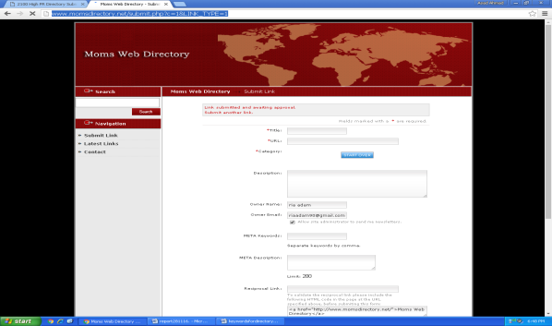
08 | http://www.diroon.com/submit.php?c=359&LINK_TYPE=2 | 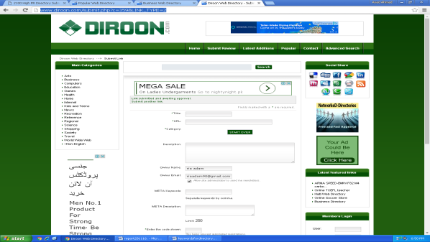
09 | http://www.seanwise.com/submit.php?c=1&LINK_TYPE=1 | 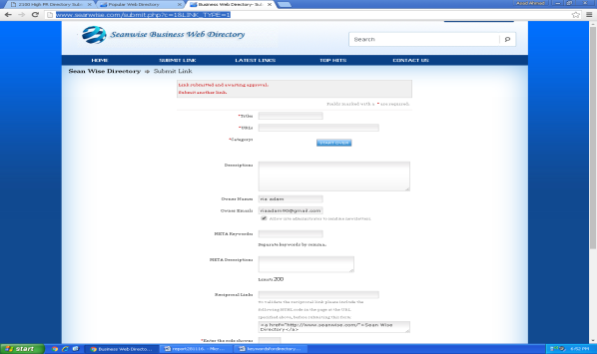
10 | http://www.livepopular.com/submit.php?c=125&LINK_TYPE=6 | 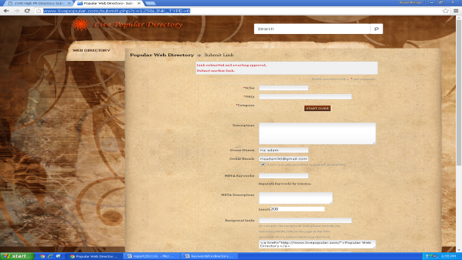
11 | http://www.reddit-directory.com/submit.php?c=10
12 | http://www.directory-listingsnow.org/submit.php?c=18 | 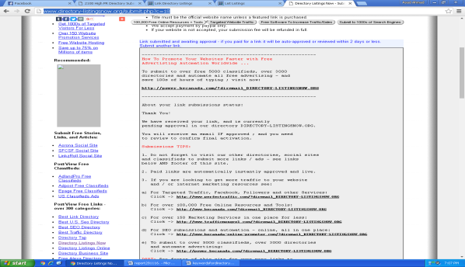
13 | http://www.freedirectory-listings.org/submit.php?c=18 | 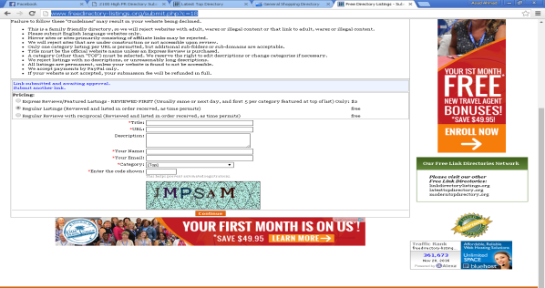
14 | http://www.generalshoppingdirectory.com/submit.php?c=318&LINK_TYPE=9 | 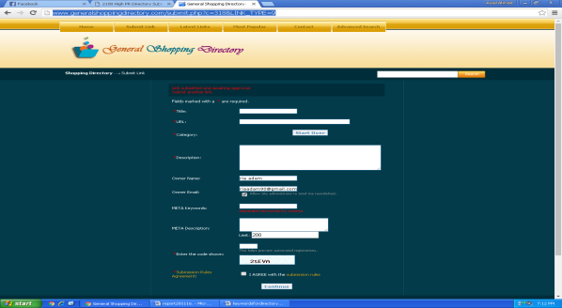
15 | http://www.business-web-directorysite.org/submit.php?c=18 | 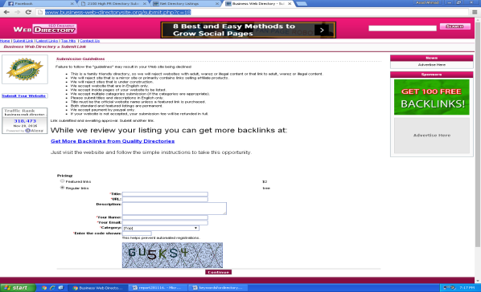
16 | http://www.netdirectorylistings.org/submit.php?c=18 | 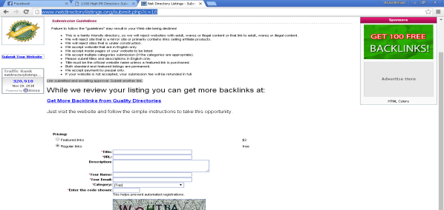
17 | http://www.generaldirectorylistings.org/submit.php?c=13&LINK_TYPE=1 | 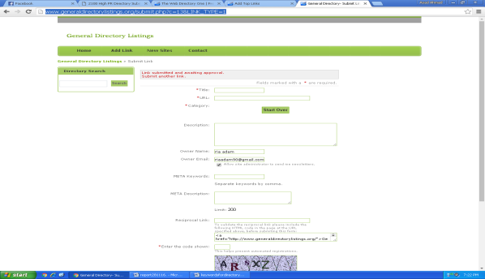
18 | http://www.thedirectory1.com/submit?c=667&LINK_TYPE=1 | 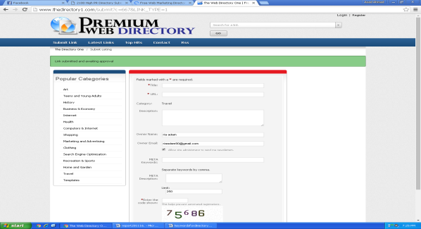
19 | http://www.web-marketing-directory.com/submit?c=291&LINK_TYPE=1 | 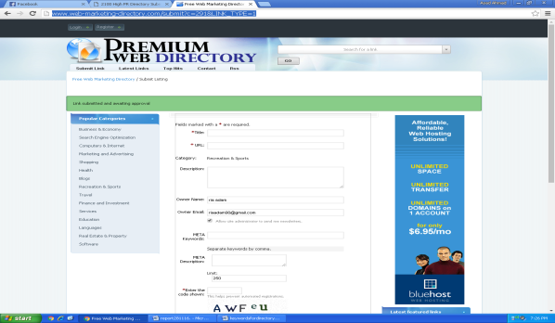
20 | http://www.10stardirectory.com/SubmitLink/getSubmitedRes | 